
Department of Mechanical Engineering

EMCH 368
MECHATRONICS

Lab 08
Servo and DC Motors

Last Edited: 3/2/2024 by J. Vaught

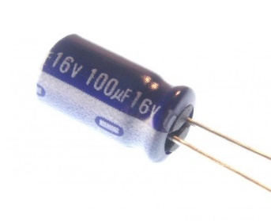
A capacitor is a component that plays a crucial role in electrical circuits by storing and releasing electrical energy. It achieves this by charging up to the circuit's voltage when the applied voltage is higher, thereby absorbing energy, and discharging when the circuit's voltage drops, thus providing energy back to the circuit. This function is particularly beneficial for smoothing out voltage fluctuations, which is essential for the stable operation of sensitive electronic devices such as sensors and motors.

Capacitors function by accumulating charge across two conductive plates, which are divided by a non-conductive substance known as a dielectric. Upon the application of voltage, an electric field emerges through the dielectric, leading to the accumulation of positive charge on one plate and negative charge on the opposing plate. This unique characteristic of storing and subsequently releasing charge renders capacitors invaluable in various electrical circuit applications. They are extensively used for filtering unwanted noise from signals, buffering electrical energy, and coupling different parts of circuits while preventing the direct flow of DC current. This versatility makes capacitors crucial components in the design and operation of nearly all electronic devices.

In terms of mathematical modeling, the behavior of a capacitor can be expressed in different domains. In the time domain, the relationship between the current through the capacitor $i(t)$ and the rate of change of voltage across it $\frac{dv}{dt}$ is given by $i\left(t\right)=C\frac{dv}{dt}$, where $C$ is the capacitance. In the s domain or laplace domain, this relationship transforms into $I\left(s\right)= s*C*V\left(s\right)- C*v\left(0\right)$, where $I(s)$and $V(s)$are the Laplace transforms of the current and voltage, respectively, and $v(0)$represents the initial voltage across the capacitor at time $t=0$. These equations are fundamental for analyzing and designing circuits involving capacitors, especially in filtering and timing applications.

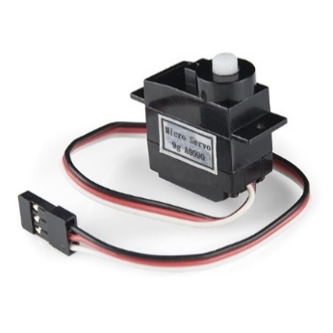
A servo motor is a specialized type of motor equipped with a reduction gear system, enabling precise control over the angle of rotation, typically limited to a range of 0 to 180 degrees. The control mechanism for a servo motor involves Pulse Width Modulation (PWM) signals, usually at a frequency of 50 Hz, which corresponds to a 20 ms period.

The angle to which the servo motor rotates is determined by the duration of the "on-time" (pulse width) within each 20 ms cycle. Typically, this "on-time" can range from about 1 ms to 2 ms: a 1 ms pulse commands the servo to rotate to its 0-degree position, while a 2 ms pulse directs it to the 180-degree position. The actual range can vary slightly between different servo models, but it generally falls within this range. Intermediate pulse widths result in corresponding intermediate positions.

Inside the servo motor, a small microcontroller or microchip deciphers the PWM signal and translates the duration of the "on-time" into a target position angle. The actual position of the servo is then continuously monitored by a feedback mechanism, commonly a potentiometer attached to the rotor.

When a servo motor operates, it draws current from the power source. This current draw varies based on the servo's position, load, and movement speed. Initially, when the servo starts to move, it draws a higher current, which correlates with its stall torque—the maximum torque it can handle before it stops moving (or stalls). The higher the stall torque, the higher the potential stall current. The operating speed, given in seconds per degrees of rotation (0.1s/60deg for ours), plays a role in current consumption. Faster movements require more immediate power, leading to spikes in current draw.

The dead bandwidth, usually given in µs (10 µs for ours), indicates the precision of control signal interpretation. A smaller dead band width means the servo can respond to finer adjustments in the control signal.

To maintain the rotor at the desired angle, the servo often employs a Proportional-Integral-Derivative (PID) controller, which adjusts the motor's position based on a set of three parameters: the Proportional (P) component, which determines the response intensity to the current angle error, defined as the difference between the desired angle (as instructed by the PWM signal) and the actual angle (as reported by the potentiometer); the Integral (I) component, which integrates the error over time, providing a cumulative offset that aids in correcting consistent positional lag or bias; and the Derivative (D) component, which considers the rate of change of the angle error, effectively predicting future error and reducing the likelihood of overshooting the target.

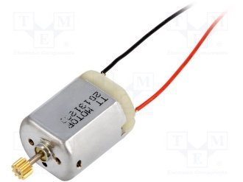
A brushed DC motor efficiently converts electrical energy into mechanical energy via the interaction between electric currents and magnetic fields. This conversion process initiates when an electric current, denoted as $I$, passes through wire coils inside the motor, which are located in a magnetic field $(B)$ established by permanent magnets or electromagnetic coils. The principles of electromagnetic induction combined with the Lorentz force, expressed as $F=I×L×B$ (where $L$ is the length of wire in the magnetic field), dictate that the current induces a force perpendicular to both the magnetic field and the current's direction. This force propels the motor's shaft, or armature, to spin.

Central to a DC motor are its primary components: the armature (the rotor), the commutator—a rotating electrical switch—and brushes. In a brushed DC motor, the armature (rotor) contains wound coils that create a magnetic field when electric current passes through. This interacts with the stationary magnetic field from the motor's magnets, causing rotation. The commutator, attached to the armature, reverses the current's direction every half turn, ensuring continuous rotation by changing the magnetic poles of the armature. The brushes maintain electrical contact with the rotating commutator to supply the armature with current. Together, these components allow the motor to efficiently convert electrical energy into mechanical motion.

The motor's operational performance, specifically its speed $(ω)$ and torque $\left(τ\right)$, hinges on the electrical current's magnitude and the magnetic field's intensity. The torque is directly influenced by the current, as per the equation $( τ=B×I×L×r)$, where $r$ is the radius to the point of force application on the armature. Conversely, the motor's speed is shaped by the applied voltage $(V)$ and countered by the back Electromotive Force (EMF), $E_{b}$, following the formula $V=E_{b}+I×R$, with R symbolizing the armature's resistance. The back EMF, which opposes the applied voltage and scales with the motor's speed, is detailed by $E_{b}=k×ω$, where $k$ is a construction-dependent constant. This EMF serves as a natural regulator, curbing the motor's speed by diminishing the net voltage and, consequently, the current through the motor as its speed climbs.

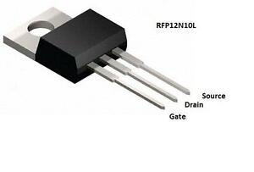
A Metal-Oxide-Semiconductor Field-Effect Transistor (MOSFET) is a critical element in modern electronics, especially valued for its ability to control high current and voltage sources with relatively low voltage inputs, such as those provided by an Arduino. The MOSFET operates under the principles of electric fields and conductivity, which differentiates it from other transistor types, like the Bipolar Junction Transistor (BJT) which relies on current control.

The structure of a MOSFET includes three crucial terminals: the source, drain, and gate. The source terminal connects to ground, establishing a reference point for current flow. The drain terminal connects to the load component, which could be a motor, LED, or other high-power element, facilitating the flow of current through this component when the MOSFET is activated. The gate terminal, distinct in its operation, is where the MOSFET's control mechanism comes into play, linked not by direct electrical connection but by an electric field to the other terminals.

When a voltage is applied to the gate terminal, it must surpass a specific threshold (denoted as $V_{th}$) to activate the MOSFET. This threshold voltage is crucial; it determines the minimum voltage needed to create an electric field strong enough to induce conductivity between the drain and source terminals. The relationship between the voltage applied to the gate ($V_{GS}$) and the resulting current from the drain to the source ($I_{D}$) in the active or 'on' state of the MOSFET is mathematically described by the equation:
$$[I_{D}=k^{'}\left(\frac{W}{L}\right){\left(V_{GS}-V_{th}\right)}^{2}]$$
In this equation, $(I_{D})$ represents the drain-source current, or the flow of electricity through the MOSFET from the drain to the source. The term $(k^{'})$ is a constant specific to the MOSFET's construction, reflecting the device's inherent ability to conduct current. The ratio $(W/L)$ represents the physical dimensions of the MOSFET's channel: $(W)$ is the channel's width, and $(L)$ is its length. Typically, a wider channel (larger $(W)$) or a shorter channel (smaller $(L)$) makes it easier for current to flow, enhancing the device's conductance.

The voltage applied between the gate and source terminals, denoted as $(V_{GS})$, acts as the primary control mechanism of a MOSFET. This controlling voltage is critical in determining the operational state of the MOSFET. When $(V_{GS})$ exceeds the threshold voltage $(V_{th})$, which is the minimum voltage necessary to 'turn on' the MOSFET, it induces an electric field strong enough to lower the resistance between the drain and source terminals, thereby creating a conductive path.

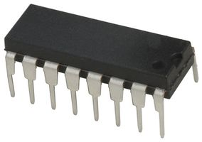
The first image illustrates a the L293D H-Bridge Integrated Circuit (IC) in a Dual In-line Package (DIP). This format is prevalent in many electronic projects, including those involving motor control. The identification of pin 1 is critical for proper IC utilization, marked by a dimple or notch at one end of the package. From this point, the pins are numbered in a counterclockwise sequence around the IC, a standard practice ensuring that each pin connects appropriately according to its designated function.

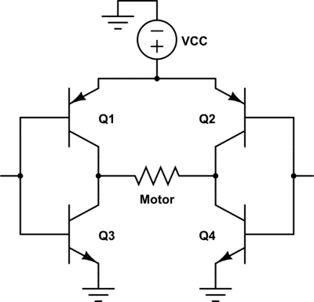
The second image depicts a schematic of an H-bridge, a fundamental component for motor control. This setup is named after its schematic representation, which resembles the letter "H". It consists of four transistors (either MOSFET of BJT), labeled Q1, Q2, Q3, and Q4. The H-bridge enables control over a motor's direction by altering the current flow. This is achieved through the strategic activation and deactivation of these transistors. For instance, activating transistors Q1 and Q4 allows current to flow in one direction across the motor, causing it to spin in one direction. Conversely, activating Q2 and Q3 reverses the current's direction, and consequently, the motor's rotation. This method of control is essential for tasks requiring bidirectional motor operation, such as in robotics or automated machinery.

In the context of the L293D or L293DE IC, these principles are integrated into a single chip. This IC contains internal switches akin to the H-bridge's transistors, facilitating direct motor control through input signals. The IC simplifies the process by consolidating the complex switching mechanism within its architecture, thus reducing the need for external components and simplifying the circuit design.

Understanding the mechanics of the H-bridge and the IC's role within this configuration is crucial for effectively implementing motor control in your projects. By applying logic to the input pins of the IC, you can manipulate the internal switches, thereby controlling the motor's speed and direction with precision. This knowledge forms the foundation for developing more complex and dynamic systems in your electronic endeavors.

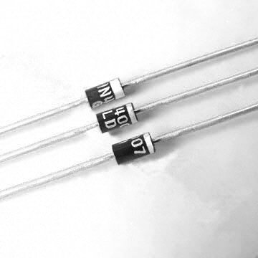
A diode is a semiconductor device that allows electricity to flow in only one direction, which is particularly useful for controlling the current in circuits with motors or other high-current or high-voltage loads. This directional property of diodes is due to their polarization, meaning their placement in a circuit is crucial for their correct operation.

When a diode is placed in a circuit, it has two operational states: forward bias and reverse bias. In the forward-biased condition, the anode (positive side) of the diode is connected to a higher voltage, and the cathode (negative side) is connected to a lower voltage. This arrangement allows current to flow through the diode with minimal resistance. For silicon diodes, the forward bias voltage — the minimum voltage required to conduct electricity — is typically around 0.6 to 0.7 volts. For other materials like germanium, this voltage is lower, around 0.3 volts.

Conversely, in the reverse-biased condition, the anode is connected to a lower voltage, and the cathode is connected to a higher voltage, preventing the current from flowing through the diode under normal conditions. However, if the reverse voltage applied across the diode exceeds a certain threshold known as the reverse breakdown voltage, the diode will start to conduct in the reverse direction, which can be destructive if the diode is not designed to handle such conditions.

The physical structure of the diode helps in identifying its orientation: the cathode is typically marked with a band on one side of the diode’s body. Ensuring the correct orientation is essential for the diode to function as intended, either allowing current flow in the forward direction or blocking it in the reverse.

In applications involving diodes, understanding these operational states—forward bias and reverse bias—is vital. It allows for the effective design of circuits, especially in protecting sensitive components from potential damage caused by reverse currents. This knowledge is also fundamental when implementing diodes for rectification, voltage regulation, signal modulation, or any task requiring controlled directionality of current.

Exercise 1: Using a Potentiometer to control a Servo Motor
Your objective is to build a circuit that meets these requirements:
- Control a servo motor's position using a dial (potentiometer).
- Include capacitors to stabilize voltage fluctuations when the motor operates.

The Arduino software includes a library for easy servo control. As servos typically rotate up to 180 degrees, and Arduino analog input ranges from 0-1023, mapping these values is necessary.

Materials:
- (1) set of long red and black jumper wires
- (1) potentiometer
- (1) servo motor
- (3) male headers
- (2) 100uF capacitors

Building the Circuit:
- Connect a red wire from the Arduino's 5V pin to the breadboard's (+) line, and a black wire from the Arduino's ground pin to the (-) line.
- Install a potentiometer on the breadboard; connect one side to 5V, the opposite side to ground, and the middle pin to the Arduino's A0 pin. This serves as the servo control dial.
- Attach male headers to the servo wires and connect them: red to 5V, black to ground, white to digital pin 9.
- Place a 100uF capacitor across the power and ground near the servo connections and another across the potentiometer's power inputs. Ensure correct capacitor polarity to prevent damage. These capacitors stabilize voltage when the servo moves, preventing dips.
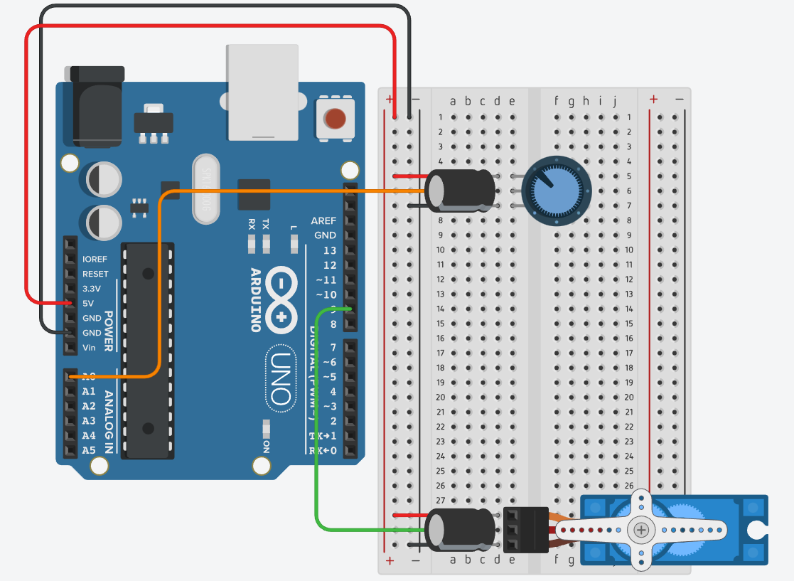
Exercise 1 Circuit
Writing the Code:

This code begins by including the Servo library, which provides easy-to-use functions for controlling servo motors. A Servo object named myServo is then initialized to represent the servo motor in the program. The sketch also defines variables for the potentiometer pin, the potentiometer value, and the servo angle. In the setup function, the servo is attached to pin 9, and serial communication is started at a baud rate of 9600 bits per second, enabling the Arduino to send data back to the computer for monitoring.

The core functionality of the sketch is contained within the loop function. Here, the value from the potentiometer is read and mapped from its original range (0 to 1023) to the range of possible servo angles (0 to 179 degrees). This mapped value is then used to set the position of the servo. Additionally, the loop function prints the current potentiometer value and the corresponding servo angle to the serial monitor, providing real-time feedback on the system's behavior. A short delay is included at the end of each loop iteration to ensure the servo has sufficient time to move to the new position before the next reading is taken.

Exercise 2: Making a button-controlled motor
Your task is to build a circuit that:
- Activates a motor when a pushbutton is pressed.
- Uses a MOSFET to connect the Arduino and the motor.
- Includes a diode to protect the circuit from the motor's back-voltage.

When the motor stops receiving power, it keeps spinning due to inertia and generates a reverse voltage. Use a diode in parallel with the motor to safely divert the voltage away from your circuit.

Materials:
- 1 set of long red and black jumper wires
- 1 switch (pushbutton)
- 1 10k-ohm resistor
- 1 MOSFET
- 1 DC motor
- 1 diode

Building the Circuit:
- Link Arduino's 5V to breadboard's (+) and ground to (-) with red and black wires.
- Install a pushbutton on the breadboard; link one side to 5V, the other to Arduino's digital pin 2 with a 10k ohm resistor to ground.
- Connect the motor to the 5V rail on the breadboard.
- Place the MOSFET on the breadboard, metal tab away from Arduino. Link gate to digital pin 9, drain to motor, source to ground.
- Attach a diode between the motor's ground and the 5V supply, stripe facing away from the Arduino.
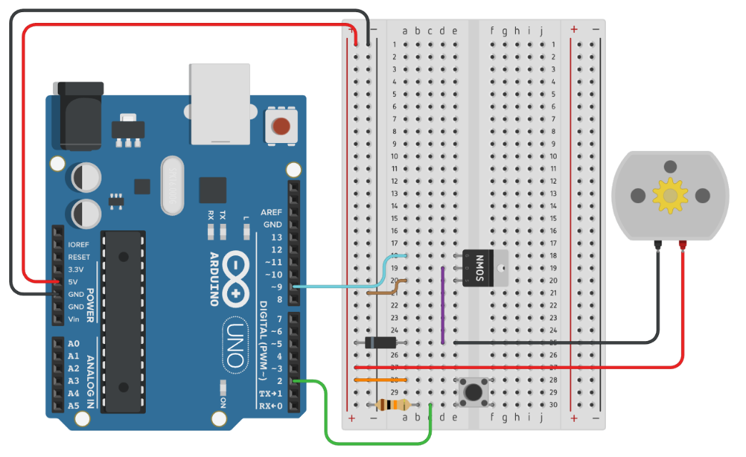
Exercise 2 Circuit
Writing the Program:
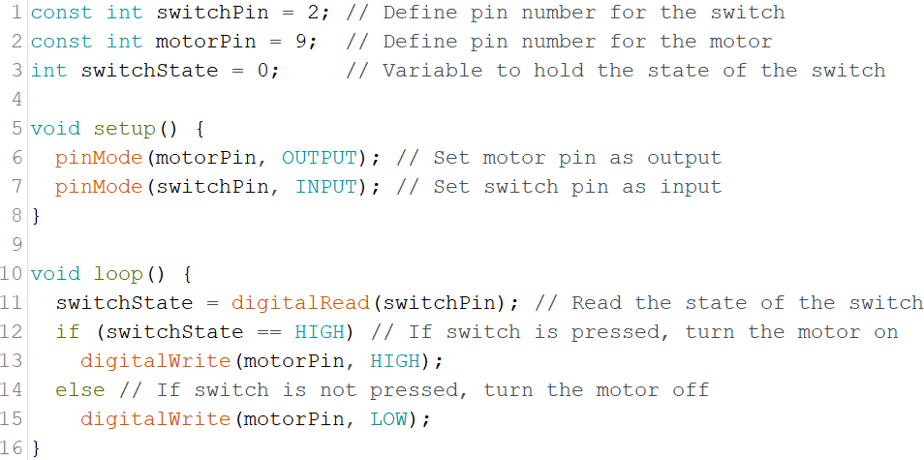
This Arduino script enables motor control via a switch. It designates digital pins for the switch (pin 2) and the motor (pin 9) and uses a variable, `switchState`, to monitor the switch's status. Within the setup function, the script sets the motor pin to output and the switch pin to input, preparing for operation. The `loop()` function continually checks the switch's state; if the switch is pressed (high state), the motor turns on; otherwise, it remains off. This code illustrates basic digital input and output handling in microcontroller programming.

Exercise 3: Dynamic Motor Control Circuit
Motors can control speed and direction beyond simple on/off states. Changing power and ground orientation reverses rotation, but this is impractical for frequent changes. Instead, we will use an H-bridge, an integrated circuit that simplifies direction control, functioning like multiple transistors.

Your objective is to build a circuit with:
- A motor controlled by a momentary pushbutton for start/stop.
- Another button to reverse the motor's direction.
- A potentiometer to vary the motor's speed.

Materials:
- 1 set of long red and black jumper wires
- 1 9V power supply
- 2 switches (pushbutton)
- 2 10k-ohm resistors
- 1 potentiometer
- 1 H-Bridge
- 1 DC motor

Building the Circuit:
- Unplug USB before adjusting the circuit.
- Keep only power and ground connected. Link ground buses; avoid linking power buses. Ensure a common ground without connecting different power sources.
- Attach your battery’s positive to one breadboard's (+) bus, and negative to the GND bus
- Add two switches: one to digital pin 4 for direction, another to digital pin 5 for on/off, both via 10k resistors.
- Install a potentiometer: one side to 5V, other to ground, middle to A0 for speed control.
- Set up the H-bridge:
  - Pin 1 to Arduino's pin 9 for enable/control.
  - Pins 2 and 7 to digital pins 3 and 2 for direction.
  - Pin 16 to 5V for power.
  - Connect the motor to pins 3 and 6.
  - Pin 8 to the power supply, ensuring separate 9V and 5V lines but shared ground.
  - Ground pins 4 and 5.
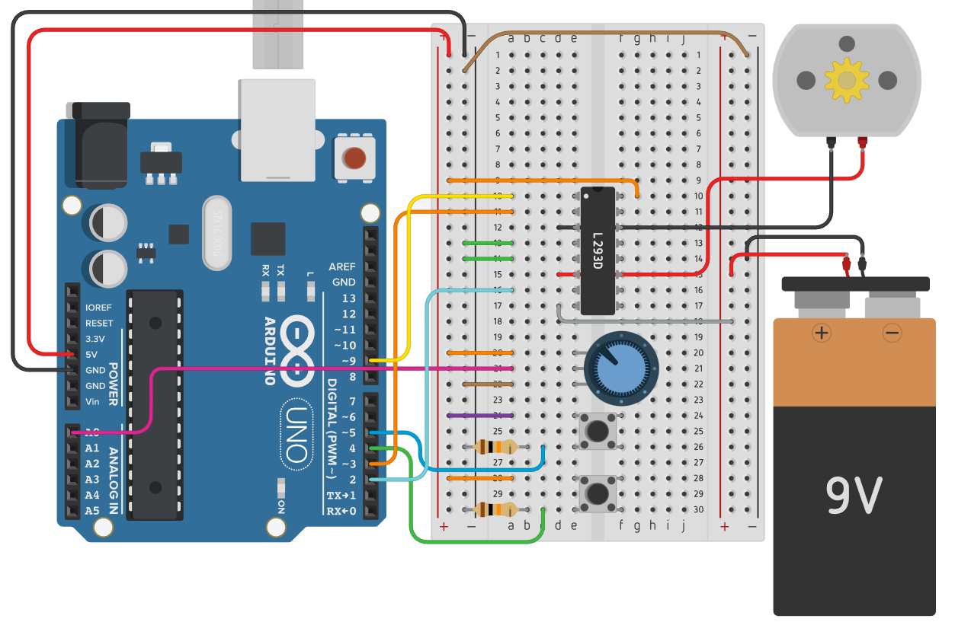
Exercise 3 Circuit

Writing the Program:
We will delve into a fundamental concept in Arduino programming known as "libraries." While we've utilized libraries previously, today's focus is on creating our own custom library.

Start by launching a new Arduino sketch as you normally would. However, this time, our initial steps diverge from simply writing code within the main sketch area. Instead, we're going to structure our code using libraries. To begin, create a new tab or file within the Arduino IDE by pressing `Ctrl+Shift+N` (or `Command+Shift+N` on MacOS). Name this new file `Motor368.h`. Repeat the process to create another file, this time naming it `Motor368.cpp`.

Once you have both files set up, navigate to the `Motor368.h` tab. Here, we'll start laying the groundwork for our library, essentially "defining" the structure and functionality of our custom library in this header file. This will involve specifying the functionalities we want our motor control library to have, such as controlling the motor's speed and direction.

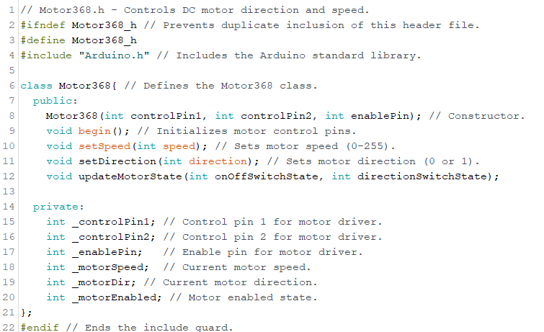
Figure 1: Motor368.h code
The header file defines the ` Motor368` class, part of a custom Arduino library for controlling a DC motor's direction and speed. The class is designed to provide an easy interface for motors, setting motor speed, and defining rotation direction.

The `Motor368` constructor initializes the motor with designated control and enable pins. The `begin()` method prepares the motor's pins for operation. The `setSpeed()` method allows the adjustment of the motor's speed within a 0-255 range, translating to stopped to maximum speed. The `setDirection()` method enables the setting of the motor’s rotational direction, facilitating reversible operations. The `updateMotorState()` method updates the motor's operational state based on external on/off and direction switch inputs, providing dynamic control in response to user interaction or automated systems. Private variables store pin configurations and current motor states, ensuring controlled and safe operations.

Note that we put an underscore (‘_’) before the variable names of private members. This is NOT required, but a good practice.
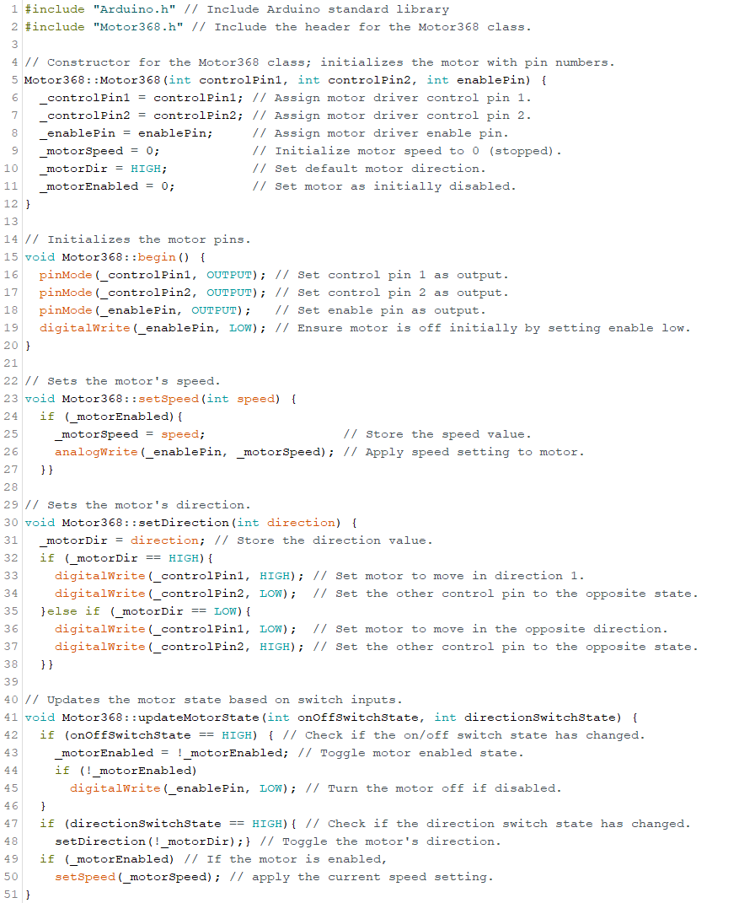
Figure 2: Motor368.cpp Code

In the ` Motor368` class implementation, the constructor initializes the motor with designated control and enable pin numbers, setting default values for speed, direction, and the enabled state to ensure safe startup conditions. The `begin()` method sets the specified motor control and enable pins to output mode and ensures the motor is initially turned off, enhancing operational safety.

The `setSpeed()` method allows the adjustment of the motor's speed by accepting an integer value, which it applies to the motor using pulse-width modulation (PWM), facilitating precise speed control. The `setDirection()` function enables the motor to switch between two directions, determined by the state of two control pins. This function manipulates the electrical flow through the motor, thereby changing its rotational direction.

Moreover, the `updateMotorState()` method dynamically responds to external inputs from on/off and direction switches. It toggles the motor’s enabled state and direction based on the current state of these switches. If the motor is enabled, this method also ensures that the most recent speed setting is applied. This mechanism allows for real-time control of the motor, adapting to user input or automated systems.

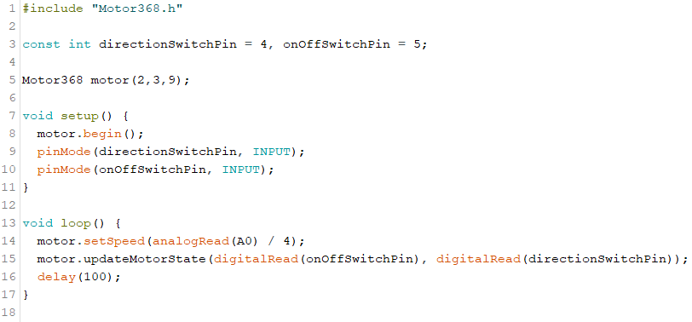
Figure 3: Sketch Code
Finally, the sketch integrates with the `Motor368` library to control a DC motor, managing its speed and direction based on external inputs. Pin numbers for motor control, enabling the motor, and switches for direction and on/off control are defined at the beginning. Additionally, a potentiometer is used for variable speed control.

In the `setup()` function, the motor is initialized, and pin modes for the direction and on/off switches are set to input, preparing the system for operation. The `loop()` function continuously reads the states of the on/off and direction switches. It updates the motor's speed based on the potentiometer's value, allowing for dynamic speed adjustments. The motor's operational state and direction are then updated according to the switch inputs, ensuring that changes in switch states directly affect the motor's behavior. The sketch also tracks the previous states of the switches, allowing for detection of state changes and minimizing redundant commands to the motor, which is essential for efficient and responsive motor control in laboratory setups and mechanical projects.

Lab 8 Code Appendix (in order of appearance):

#include – used to import outside libraries. Gives the programmer access to a large group of standard C libraries and libraries made specifically for Arduino

servo.attach(pin#) – attaches the Servo variable to a pin

servo.write(angle) – Sets the angular position of the shaft, moving the shaft in that orientation

Go to https://www.arduino.cc/reference/en/ for details on the specifics of certain code references, operators, and statements.

Lab Grading Rubric:
- Exercise 3 fully built & functioning (20 points)
- Exercise 2 fully functioning (5 points)
- Exercise 1 fully functioning (5 points)
- Understanding of material (20 points)
  - Diodes
  - Capacitors
  - DC motors
  - Servo motors
  - H-Bridges
  - MOSFETS
  - Libraries in C++

